Load Utilization Framework
Space-Based Metric for 53' Step Deck Trailers

1. Overview
This framework defines how to measure load utilization for COT shipments. The primary metric is Space Utilization - the percentage of trailer capacity consumed by loaded products, accounting for both horizontal (length) and vertical (stacking) efficiency.
Key principles:
- Each position on the trailer consumes length based on the longest product in that position
- Full stacks receive full credit; partial stacks are penalized proportionally
- Mixed products can share a position and combine to fill vertical space

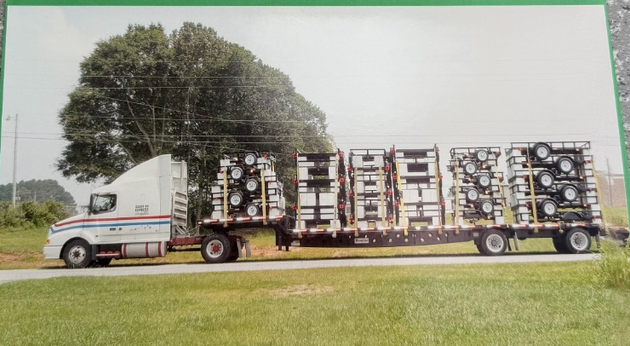

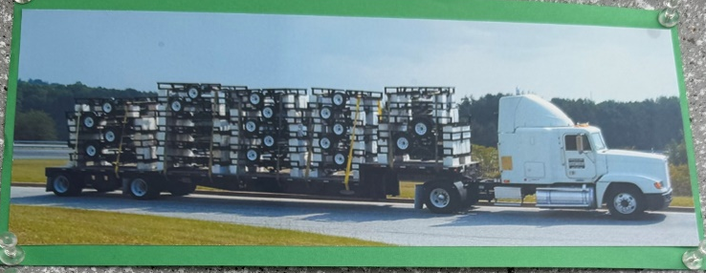

Figure 1: Examples of fully loaded COT trailers showing stacked products

2. Trailer Specifications

2.1 Trailer Types
COT primarily uses 53' step deck trailers for shipping. Alternative trailer types include:
- Step Deck (Primary): Two-level loading surface with 10' upper deck and 43' lower deck. Used for most USA, UTA, and DUMP shipments.
- Flatbed: Single-level 53' loading surface. May be used when step deck is unavailable or for specific product configurations.
- Wedge Trailer: Specialized trailer automatically used for Equipment (HDEQ) category units. Features angled design for loading heavy equipment.
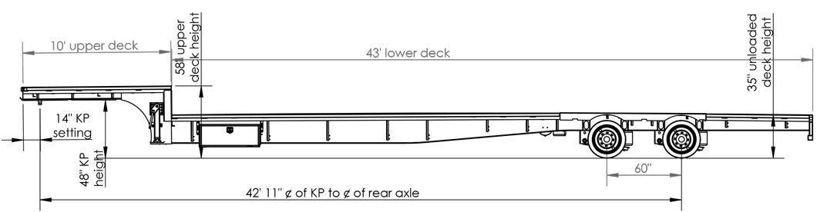
Figure 2: 53' Step Deck Trailer Specifications
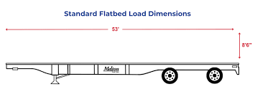
Figure 3: Standard 53' Flatbed Trailer
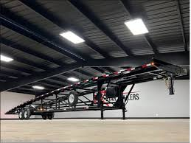
Figure 4: Wedge Trailer (used for Equipment category)

2.2 Step Deck Loading Zones
The step deck trailer has two distinct loading zones with physical constraints that must be considered:
Zone | Length | Product Constraint | Notes
Upper Deck | 10' | Length ≤ 10' ONLY | Smaller products only
Lower Deck | 43' | All products | Main loading area
Total | 53' | — | Combined for utilization calculation

3. Physical Capacity Check
Before calculating utilization percentage, verify the load physically fits on the trailer.

3.1 Capacity Check Process
- Classify each product: Length ≤ 10' can use either deck; Length > 10' is lower deck only
- Calculate lower deck requirement: Sum of (Positions × Length) for all products that MUST go on lower deck
- Check lower deck fit: If lower deck requirement > 43', load exceeds capacity
- Allocate remaining space: Small products (≤10') can overflow to upper deck if lower deck is full

3.2 Positions Available by Product Length
Product Length | Lower Deck (43') | Upper Deck (10') | Max Positions
7' | 6 positions | 1 position | 7
10' | 4 positions | 1 position | 5
12' | 3 positions | — | 3
16' | 2 positions | — | 2
20' | 2 positions | — | 2
22' | 1 position | — | 1
25'+ | 1 position | — | 1

4. Utilization Calculation

4.1 Position Credit Calculation
Each position's credit depends on how fully the vertical stack is utilized:
Position Credit = (Vertical Fill %) × (Length / 53')
Where:
- Vertical Fill % = Units in Position / Max Stack Height for that position
- Length = Length with Tongue of the longest product in the position

4.2 Full Stack vs. Partial Stack
- Full stack (100% fill): Full credit → Length / 53'
- Partial stack: Penalized → (Units / Max Stack) × (Length / 53')

4.3 Mixed Product Positions
Different products can share a position to maximize vertical fill:
- Combine vertical fill percentages from each product
- Use the longest product's length as the position footprint
- Cap total vertical fill at 100%

4.4 Total Load Utilization
Load Utilization = Σ (Position Credits)

5. Grading Scale
Load utilization grades based on total credit earned:
Grade | Utilization | Description | Action
A | ≥ 85% | Excellent | Optimal load
B | 70% - 84% | Good | Acceptable
C | 55% - 69% | Fair | Review for consolidation
D | 40% - 54% | Poor | Consolidation needed
F | < 40% | Failing | Hold for more orders

6. Worked Examples

Example 1: Single Product with Partial Stack
Load: 17× 5X8GW2K (Length: 7', Max Stack: 6)
Capacity Check: 7' products can use upper deck. Need 3 positions × 7' = 21'. Lower deck (43') + upper deck (10') = 53' available. ✓ FITS
Position | Units | Fill % | Length | Credit
1 | 6 | 6/6 = 100% | 7' | 7' × 100% = 7.0'
2 | 6 | 6/6 = 100% | 7' | 7' × 100% = 7.0'
3 (partial) | 5 | 5/6 = 83% | 7' | 7' × 83% = 5.8'
TOTAL | 17 |  |  | 19.8'
Utilization = 19.8' / 53' = 37.4% → Grade F

Example 2: Mixed Products Completing a Stack
Load: 15× 5X8GW2K (7', stack 6) + 1× 6X12DUMP (16', stack 3)
Capacity Check: DUMP at 16' requires lower deck. SA at 7' can use either. Total lower deck need: 16' (mixed position) + 14' (2× SA stacks) = 30' < 43'. ✓ FITS
The 15 SAs fill 2 full stacks (12 units) with 3 remaining. The DUMP can stack with the partial SA stack since 3/6 + 1/3 ≈ 83% vertical fill. Use DUMP's longer length (16') for that position.
Position | Contents | Fill % | Length | Credit
1 | 6× SA | 6/6 = 100% | 7' | 7.0'
2 | 6× SA | 6/6 = 100% | 7' | 7.0'
3 (mixed) | 3× SA + 1× DUMP | 3/6 + 1/3 = 83% | 16' | 16' × 83% = 13.3'
TOTAL | 16 units |  |  | 27.3'
Utilization = 27.3' / 53' = 51.5% → Grade D

Example 3: Perfect Mixed Stack (Full Vertical Fill)
Load: 15× 5X8GW2K (7', stack 6) + 2× 6X12DUMP (16', stack 3)
Capacity Check: Same logic as Example 2. ✓ FITS
Same as above, but with 2 DUMPs. Position 3 now has 3 SAs (3/6 = 50%) + 2 DUMPs (2/3 = 67%). Combined = 117%, but we cap at 100%.
Position | Contents | Fill % | Length | Credit
1 | 6× SA | 100% | 7' | 7.0'
2 | 6× SA | 100% | 7' | 7.0'
3 (mixed) | 3× SA + 2× DUMP | 50% + 67% → 100% | 16' | 16' × 100% = 16.0'
TOTAL | 17 units | All 100% |  | 30.0'
Utilization = 30.0' / 53' = 56.6% → Grade C
Key insight: Adding 1 more DUMP improved utilization from 51.5% to 56.6% by completing the vertical fill on position 3.

Example 4: Large Products Exceeding Physical Capacity
Load: 11× 7X16GW2BRK (20', stack 5)
Capacity Check: 20' products can ONLY go on lower deck (43'). Position 1: 20' → 23' remaining. Position 2: 20' → 3' remaining. Position 3: Needs 20' but only 3' available, and 20' > 10' so cannot use upper deck. ✗ EXCEEDS CAPACITY
Position | Units | Fill % | Length | Credit
1 | 5 | 5/5 = 100% | 20' | 20.0'
2 | 5 | 5/5 = 100% | 20' | 20.0'
3 (won't fit) | 1 | — | 20' | N/A
MAX FIT | 10 |  |  | 40.0'
Maximum capacity: 10 units (2 full stacks)
Utilization at max: 40.0' / 53' = 75.5% → Grade B
Key insight: Even though 75.5% < 100%, this load is at physical capacity due to deck constraints. The 11th unit must go on a second truck. This is why capacity check must happen BEFORE utilization calculation.

Example 5: Well-Optimized Mixed Load
Load: 24× 5X8GW2K (7', stack 6) + 10× 6X12GW (16', stack 5)
Capacity Check: 6X12 at 16' requires lower deck: 2 positions × 16' = 32'. 5X8 at 7' needs 4 positions × 7' = 28'. Total = 60' > 53'. ✗ EXCEEDS CAPACITY
This load would need to be split across two trucks.

7. Reference: Common Product Parameters
Key products from the Master Load Building Cheat Sheet:
Category | Dimension | Length | Max Stack
USA | 5X8 | 7' | 6
USA | 5X8 (HS) | 12' | 3-5
USA | 6X12 | 16' | 5
UTA | 7X16 | 20' | 5
UTA | 7X18 | 22' | 5
HDEQ | 7X20 | 25' | 5
HDEQ | 8.5X20 | 27' | 3-5
DUMP | 6X12 | 16' | 3
DUMP | 7X14 | 18' | 3

8. Quick Reference Summary

8.1 Process Flow
- Capacity Check: Verify load fits within deck constraints (43' lower + 10' upper for ≤10' products)
- Calculate Position Credits: (Vertical Fill %) × (Length / 53') for each position
- Sum Credits: Total utilization = Σ(Position Credits)
- Assign Grade: A (≥85%), B (70-84%), C (55-69%), D (40-54%), F (<40%)

8.2 Key Formulas
Component | Formula
Lower Deck Positions | FLOOR(43' / Product Length)
Upper Deck Positions | FLOOR(10' / Product Length) — only if Length ≤ 10'
Full Stack Credit | Length / 53'
Partial Stack Credit | (Units / Max Stack) × (Length / 53')
Mixed Position Fill % | Σ(Units / Max Stack) for each product, cap at 100%
Mixed Position Length | Longest product's Length with Tongue
Load Utilization | Σ(Position Credits) — target ≥ 85%

